**Lab Report**

Course Name : Electrical Circuits

Course Code : CSE209 LAB

Section No : 04

Experiment NO : 05

Experiment name : Verification of Superposition Theorem

**Submitted to**

Course instructor : Rashedul Amin Tuhin

Senior lecturer

Computer science and engineering

**Submitted by**

Name: Apurba Roy Ajay

Student’s ID : 2018-3-60-063

Department : Computer science and engineering

**Date of report submission : /09/2020**

**Objective:**

1. To verify the superposition theorem theoretically, experimentally, and using PSpice simulation.

Circuit Diagram:

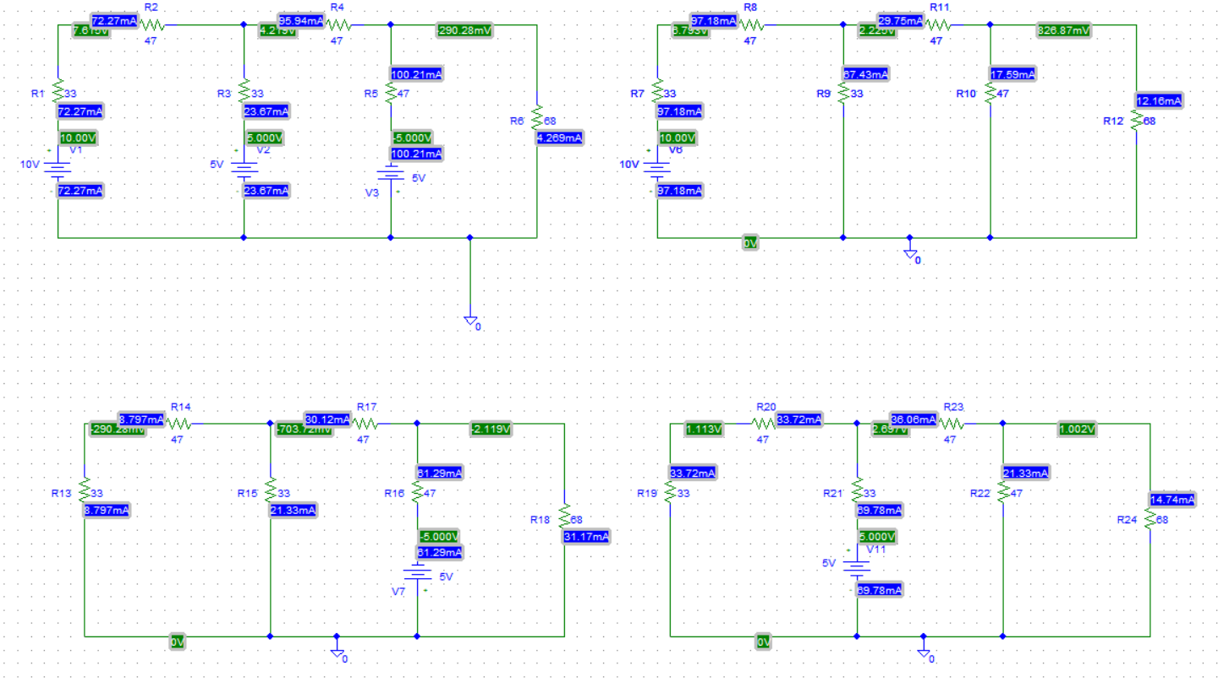

**Experimental Datasheet:**

|  |  |  |  |  |  |  |  |
| --- | --- | --- | --- | --- | --- | --- | --- |
| Measured Value of *E*1 (V) | Measured Value of *E*2 (V) | Measured Value of *E*3 (V) | Measured value of *IL* with all sources active  (mA) | Measured value of *IL*1 with  only *E*1  active (mA) | Measured value of *IL*2 with  only *E*2  active (mA) | Measured value of *IL*3 with  only *E*2  active (mA) | Measured values of resistors () |
| 10 V | 5 V | 5 V |  |  |  |  | *R*1= 33 *R*2 =  *R*3 =  *R*4 =  *R*5=  *RL* =­­­ |

**Answer to the Post-Lab Question:**1.answer:

Circuit:

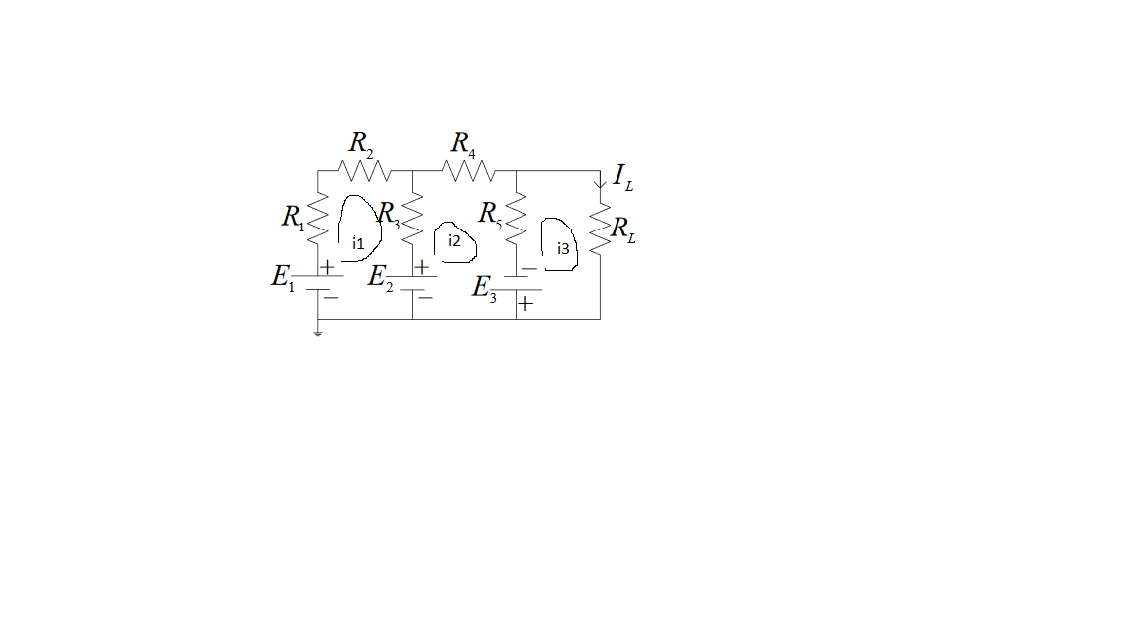 Here, $E_{1}=10V, E_{2}=5V, E_{3}=5V,R_{1}=33Ω, R_{2}=47Ω$, $R_{3}=33Ω,R_{4}=47Ω,R_{5}=47Ω,R_{L}=68Ω$

Appling KVL at mesh 1,2 &3, $113i_{1}-33i_{2}=5$ $-33i_{1}+127i_{2}-47i_{3}=10$ $-47i_{2 }+115i_{3}=-5$

Slove those equation.  
From the figure, $i_{3}= I_{L}= -4.27 mA$

Now, Circuit with $E_{1}$ source active.

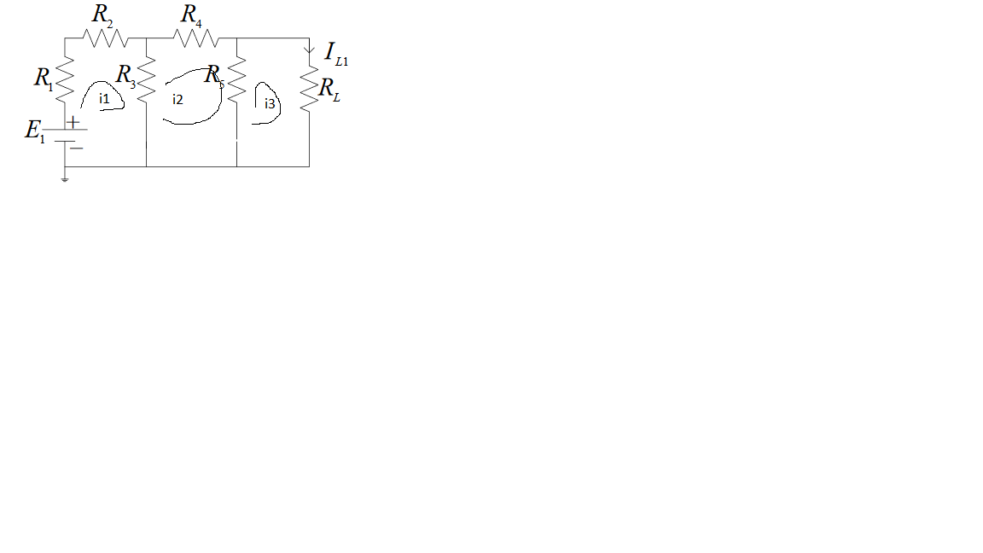 Appling KCL at mesh 1,2 &3, $113i_{1}-33i_{2}=10$ $$-33i_{1}+127i_{2}-47i_{3}=0 \\ -47i_{2 }+115i_{3}=0$$
 Slove those equation.  
From the figure, $i_{3}= I_{L2}= 12.16 mA$

Now, Circuit with $E_{2}$ source active.

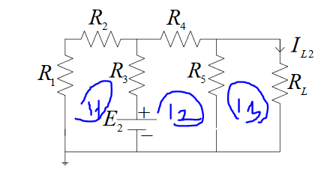

Appling KCL at mesh 1,2 &3, $113i_{1}-33i_{2}=-5$ $$-33i_{1}+127i_{2}-47i_{3}=5 \\ -47i_{2 }+115i_{3}=0$$
 From the figure, $i_{3}= I_{L2}= 14.73 mA$

When, Circuit with E3 source active.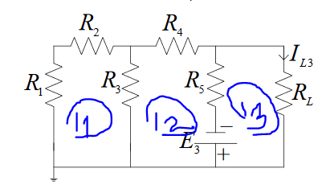

Appling KCL at mesh 1,2 &3, $113i_{1}-33i_{2}=0$ $$-33i_{1}+127i_{2}-47i_{3}=5 \\ -47i_{2 }+115i_{3}=-5$$
 Slove those equation.  
From the figure, $i_{3}= I_{L3}= -31.17 mA$

The superposition theorem is, $I_{L}=$ $I_{L1}+I_{L2}+I_{L3}$ $⟹$
   
 12.16+14.73-31.17 $⟹$ 
 -4.27  
 So, the superposition theorem holds (Showed)

**Conclusion :**

We connect this circuit using Pspice software.I think if we could do this same experiment in the lab, the measure value would change a little bit and most importantly we could learn how to connect the circuit for real life.